**Error Metrics:**

An **Error Metric** is a type of **Metric** used to measure the **error** of a forecasting model. They can provide a way for forecasters to quantitatively compare the performance of competing models.

[Mean Squared Error (MSE)](https://en.wikipedia.org/wiki/Mean_squared_error)

**MSE** is the average of the squared error that is used as the loss **function** for least squares regression: It is the sum, over all the data points, of the square of the difference between the predicted and actual target variables, divided by the number of data points. The mean squared error tells **you** how close a regression line **is** to a set of points. It does this by taking the distances from the points to the regression line (these distances **are** the “errors”) and squaring them. The squaring **is** necessary to remove any negative signs. It also gives more weight to larger differences.

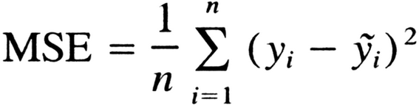

As it squares the differences, it penalizes even a small error which leads to over-estimation of how bad the model is. It is preferred more than other metrics because it is differentiable and hence can be optimized better. The main reason being that in MSE by squaring the errors, the outliers (which usually have higher errors than other samples) get more attention and dominance in the final error and impacting the model parameters.

[Mean Absolute Error (MAE)](https://en.wikipedia.org/wiki/Mean_absolute_scaled_error)

MAE measures the average magnitude of the errors in a set of predictions, without considering their direction. It’s the average over the test sample of the absolute differences between prediction and actual observation where all individual differences have equal weight

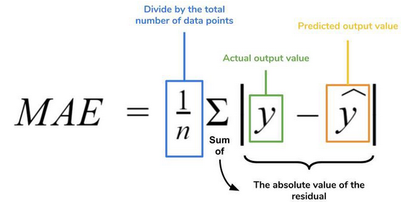

MAE is known to be more robust to the outliers than MSE. MAE is a linear score which means all the individual differences are weighted equally. It is not suitable for applications where you want to pay more attention to the outliers.

[Root Mean Square Error (RMSE)](https://en.wikipedia.org/wiki/Root-mean-square_deviation)

RMSE is a quadratic scoring rule that also measures the average magnitude of the error. It’s the square root of the average of squared differences between prediction and actual observation.

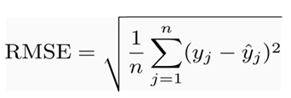

It follows an assumption that **error** are unbiased and follow a normal distribution.

[Mean Absolute Percentage Error (MAPE)](https://en.wikipedia.org/wiki/Mean_absolute_percentage_error)

The mean absolute percentage error (**MAPE**) is a statistical measure of how accurate a forecast system is. It measures this accuracy as a percentage, and can be calculated as the average absolute percent error for each time period minus actual values divided by actual values.

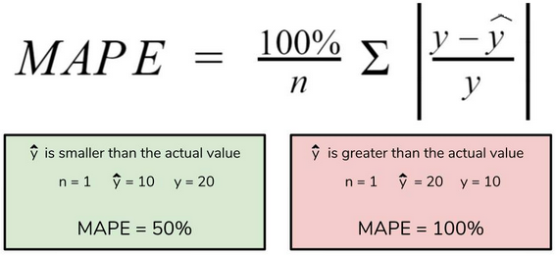

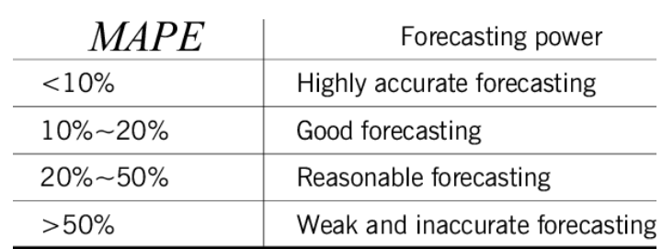

R-Squared Error

**R**-**squared** is a goodness-of-fit measure for linear regression models. This statistic indicates the percentage of the variance in the dependent variable that the independent variables explain collectively. **R**-**squared** values **range** from 0 to 1 where 0 indicates that this model doesn't fit the given data and 1 indicates that the model fits perfectly to the dataset provided.

**Adjusted R²:**

Adjusted R² depicts the same meaning as R² but is an improvement of it. R² suffers from the problem that the scores improve on increasing terms even though the model is not improving which may misguide the researcher. Adjusted R² is always lower than R² as it adjusts for the increasing predictors and only shows improvement if there is a real improvement.t

Image for post